**[TEORI] TUGAS BASIS DATA 4**

**“Merancang ERD Sekaligus Mapping Database Nota Pembelian”**



Disusun Oleh:

Aldow Fan Dzikri (NRP. 3121500022)

1 D3 ITA

Dosen Pengampu:

Arif Basofi S.Kom, M.T.

**PROGRAM STUDI D3 TEKNIK INFORMATIKA**

**DEPARTEMEN TEKNIK INFORMATIKA DAN KOMPUTER**

**POLITEKNIK ELEKTRONIKA NEGERI SURABAYA 2022**

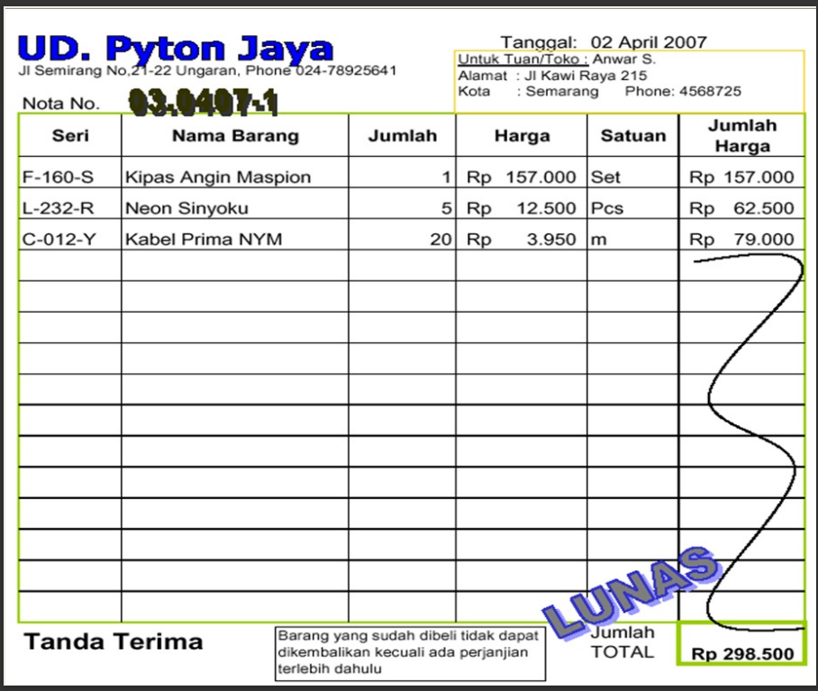

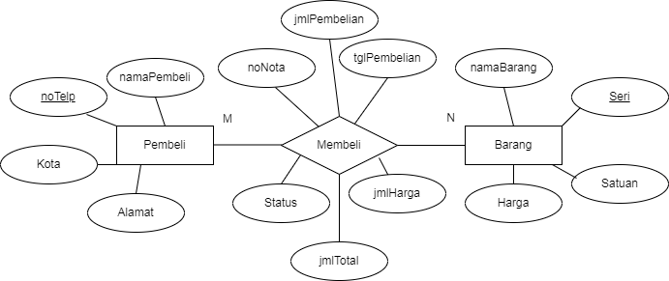**ERD Nota Pembelian diatas:**

**Mapping dari ERD Nota Pembelian diatas:**

**Pembeli**

|  |  |  |  |
| --- | --- | --- | --- |
| noTelp (PK) | namaPembeli | Alamat | Kota |

**Barang**

|  |  |  |  |
| --- | --- | --- | --- |
| Seri (PK) | namaBarang | Harga | Satuan |

**Membeli**

|  |  |  |  |  |
| --- | --- | --- | --- | --- |
| noNota(PK) | noTelp | tglPembelian | Jmltotal | Status |

**Detail_Beli**

|  |  |  |  |
| --- | --- | --- | --- |
| noNota (PK) | noSeri | jmlBarang | jmlHarga |

(PK)