LAPORAN KONSEP JARINGAN
[Praktikum 05] Routing Static

Disusun Oleh:
Aldow Fan Dzikri (NRP. 3121500022)
2 D3 ITA

Dosen Pengampu:
Fitri Setyorini ST. M.Sc

PROGRAM STUDI D3 TEKNIK INFORMATIKA
DEPARTEMEN TEKNIK INFORMATIKA DAN KOMPUTER
POLITEKNIK ELEKTRONIKA NEGERI SURABAYA
2022

Topology 1

Screenshot topology jaringan:
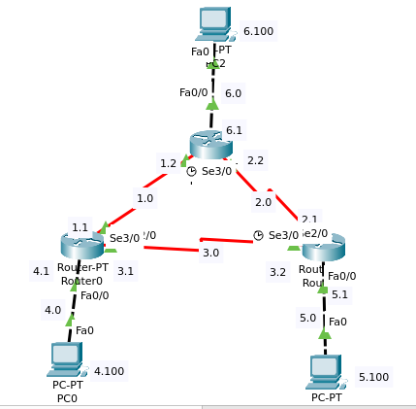

Hasil show ip route ditiap router
1. Route0

2. Route1

3. Route2

Topology 2

Screenshot topology jaringan:
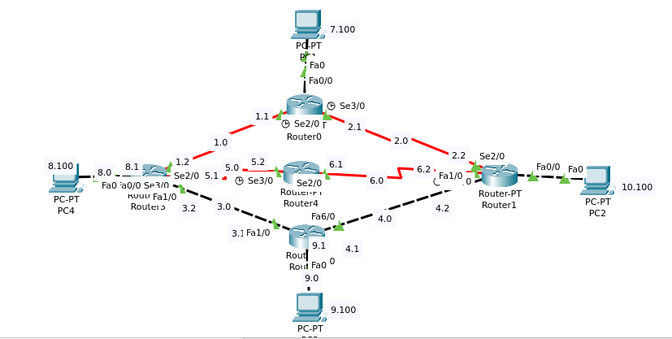
Hasil show ip route ditiap router
1. Route0

2. Route1

3. Route2

4. Route3

Topology 3

Screenshot topology jaringan:
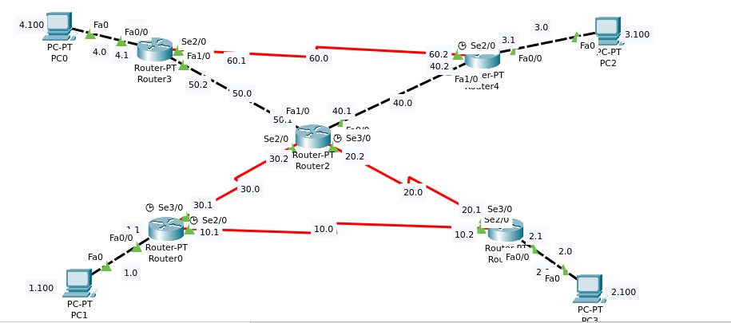

Hasil show ip route ditiap router
1. Route0
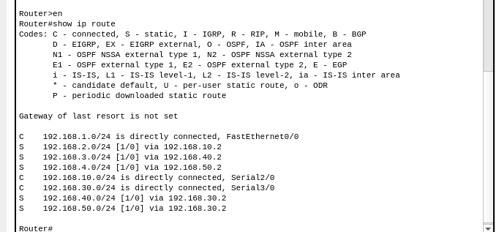

2. Route1
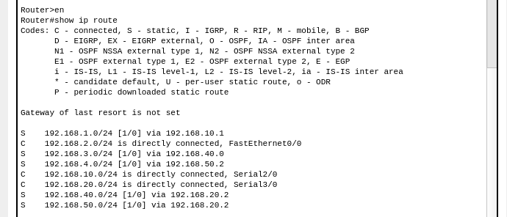

3. Route2
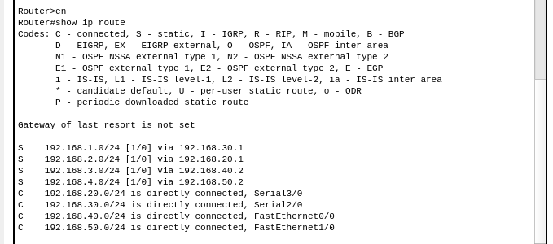

4. Route3
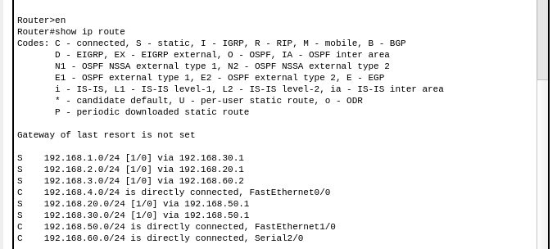

5. Route4

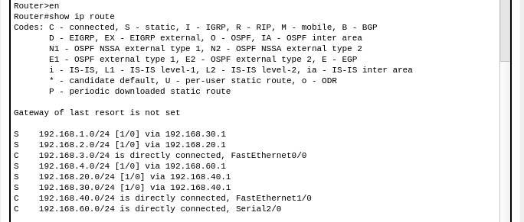

Topology 4

Screenshot topology jaringan:
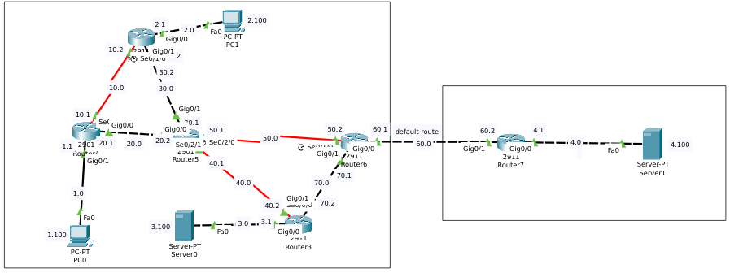
Hasil show ip route ditiap router
1. Route0

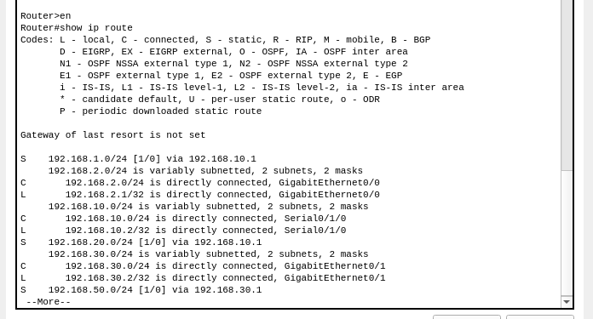

2. Route4
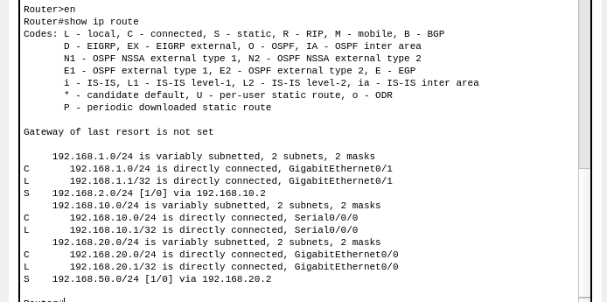

3. Route6
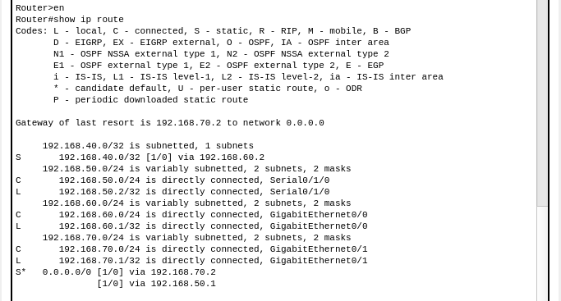

4. Route3
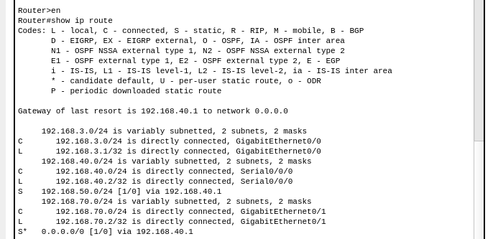

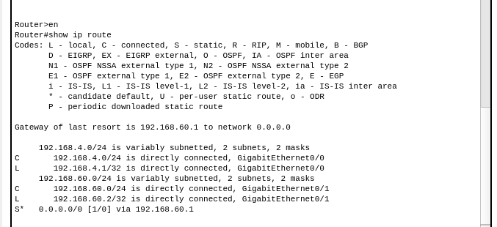
5. Route7

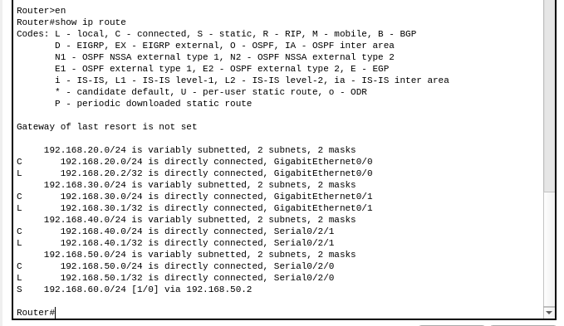
6. Route5

