LAPORAN KONSEP JARINGAN
[Teori 01] Analisis IP header

Disusun Oleh:
Aldow Fan Dzikri (NRP. 3121500022)
2 D3 ITA

Dosen Pengampu:
Iwan Syarif S.Kom., M.Kom., M.Sc., Ph.D.

PROGRAM STUDI D3 TEKNIK INFORMATIKA
DEPARTEMEN TEKNIK INFORMATIKA DAN KOMPUTER
POLITEKNIK ELEKTRONIKA NEGERI SURABAYA
2022

1. Select the first ICMP Echo Request message sent by your computer, and expand
the Internet Protocol part of the packet in the packet details window.
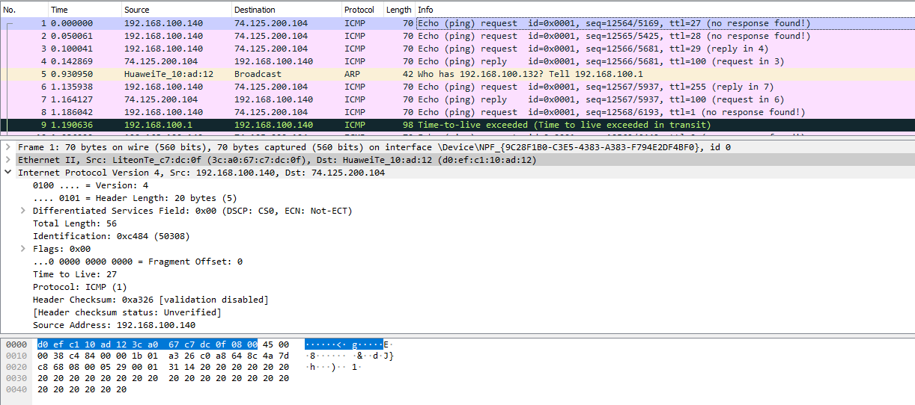
What is the IP address of your computer?
192.168.100.140
2. Within the IP packet header, what is the value in the upper layer protocol field?

3. How many bytes are in the IP header? How many bytes are in the payload of the
IP datagram? Explain how you determined the number of payload bytes.
4. Has this IP datagram been fragmented? Explain how you determined whether or
not the datagram has been fragmented.
Next, sort the traced packets according to IP source address by clicking on the Source
column header; a small downward pointing arrow should appear next to the word Source.
If the arrow points up, click on the Source column header again. Select the first ICMP
Echo Request message sent by your computer, and expand the Internet Protocol portion
in the “details of selected packet header” window. In the “listing of captured packets”
window, you should see all of the subsequent ICMP messages (perhaps with additional
interspersed packets sent by other protocols running on your computer) below this first
ICMP. Use the down arrow to move through the ICMP messages sent by your computer.
5. Which fields in the IP datagram always change from one datagram to the next
within this series of ICMP messages sent by your computer?
6. Which fields stay constant? Which of the fields must stay constant? Which fields
must change? Why?
7. Describe the pattern you see in the values in the Identification field of the IP
datagram
Next (with the packets still sorted by source address) find the series of ICMP TTLexceeded replies sent to your computer by the nearest (first hop) router.
8. What is the value in the Identification field and the TTL field?
9. Do these values remain unchanged for all of the ICMP TTL-exceeded replies sent
to your computer by the nearest (first hop) router? Why?
Fragmentation
Sort the packet listing according to time again by clicking on the Time column.
10. Find the first ICMP Echo Request message that was sent by your computer after
you changed the Packet Size in pingplotter to be 2000. Has that message been
fragmented across more than one IP datagram? [Note: if you find your packet has
not been fragmented, you should download the zip file
http://gaia.cs.umass.edu/wireshark-labs/wireshark-traces.zip and extract the ipethereal-trace-1packet trace. If your computer has an Ethernet interface, a packet
size of 2000 should cause fragmentation.3]
11. Print out the first fragment of the fragmented IP datagram. What information in
the IP header indicates that the datagram been fragmented? What information in
the IP header indicates whether this is the first fragment versus a latter fragment?
How long is this IP datagram?

